VASS Security Guide



VASS Flat File Import Instructions

Prepared for

Veteran Administration

12/30/2019

Version 1.0 Draft

Prepared by

**Lauren Hudgins,** Consultant, [Lauren.hudgins@microsoft.com](mailto:Lauren.hudgins@microsoft.com)

Revision and Signoff Sheet

Change Record

|  |  |  |  |
| --- | --- | --- | --- |
| Date | Author | Version | Change Reference |
| 10/31/19 | Lauren Hudgins | 1 | Initial draft for review/discussion |

Reviewers

|  |  |  |  |
| --- | --- | --- | --- |
| Name | Version Approved | Position | Date |
|  |  |  |  |
|  |  |  |  |
|  |  |  |  |

Table of Contents

1 Overview 4

2 VASS PCR 5

2.1 Roles 5

2.2 Teams 5

2.3 Finesse Agent ID 5

3 VASS Coach 7

4 VASS Administrator 8

5 VASS Data Import 9

6 VASS Email Template 10

**­­**

1. Overview

VA Solid Start Program (VASS) enables agents to make outbound calls to Veterans recently separate from the military. Additional security roles and settings are required to enable this functionality. VASS agents should also be able to perform UDO activities, so existing processes for granting UDO permissions to those users still applies. This document explains the minimally required privileges to perform VASS activities and does not encompass the steps to enable UDO/USD capabilities.

1. VASS PCR
   1. Roles

The following roles are required to perform VASS PCR activities.

|  |
| --- |
| Security Roles |
| VASS PCR |
| UDOPCR |

* 1. Teams

A VASS agent should be assigned to a team that is associated with their call center. So, for instance, if you are located at the Nashville call center, you must be assigned to the VASS Nashville team.

|  |
| --- |
| Teams |
| VASS Cleveland |
| VASS Columbia |
| VASS Nashville |
| VASS Philadelphia |
| VASS Phoenix |
| VASS Salt Lake City |
| VASS San Juan |
| VASS St. Louis |

* 1. Finesse Agent ID

The system will initiate an outbound call and must know the agent’s Finesse Agent ID and Extension. That information is stored on their user record.

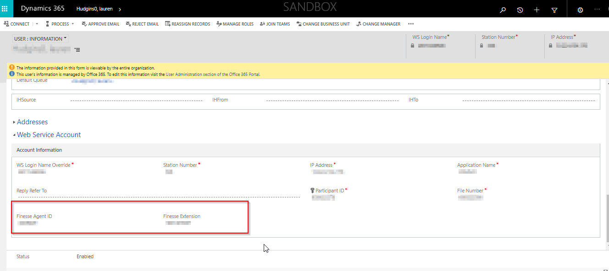

1. VASS Coach

In addition to the roles required for VASS PCRs, the following additional role is required to perform VASS Coach activities. These users will be responsible for assigning out interactions to individual agents from the Call Center Dashboard. Coaches will also have the ability to create and run reports.

|  |
| --- |
| Security Roles |
| VASS Coach |

1. VASS Administrator

In addition to the roles required for VASS PCRs, the following additional role is required to perform VASS administrator activities. These users will have access to the National Dashboard. They will be responsible for assigning out interactions to the individual call centers. They can also perform deletes of an Outbound Call Attempt that was created erroneously. They will have additional items in their sitemap including Teams, Users, and Reports.

|  |
| --- |
| Security Roles |
| VASS Administrator |

1. VASS Data Import

In addition to the roles required for VASS PCRs, the following additional role is required to perform Data Import activities required for Bulk Assignment from the National view to individual Call Centers. These users will be able to export interactions to Excel and reimport them after modifying the owner.

|  |
| --- |
| Security Roles |
| VASS Data Import |

1. VASS Email Template

In addition to the roles required for VASS PCRs, the following additional role is required to create and maintain email templates used for sending emails to Veterans.

|  |
| --- |
| Security Roles |
| VASS Email Templates |